FOR AN ORDER

Select “Options” then Select “Edit” OR “Copy”

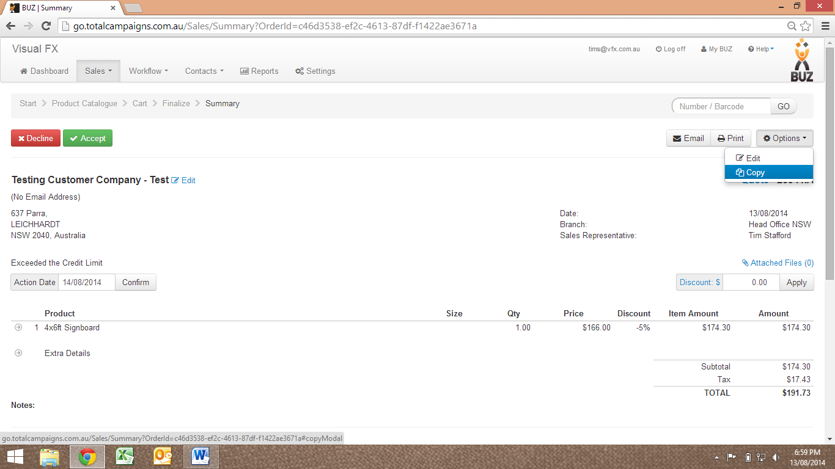

FOR A PRODUCT LINE

Select “Options” then Select “Edit” OR “Copy”

