Select “New Sale”

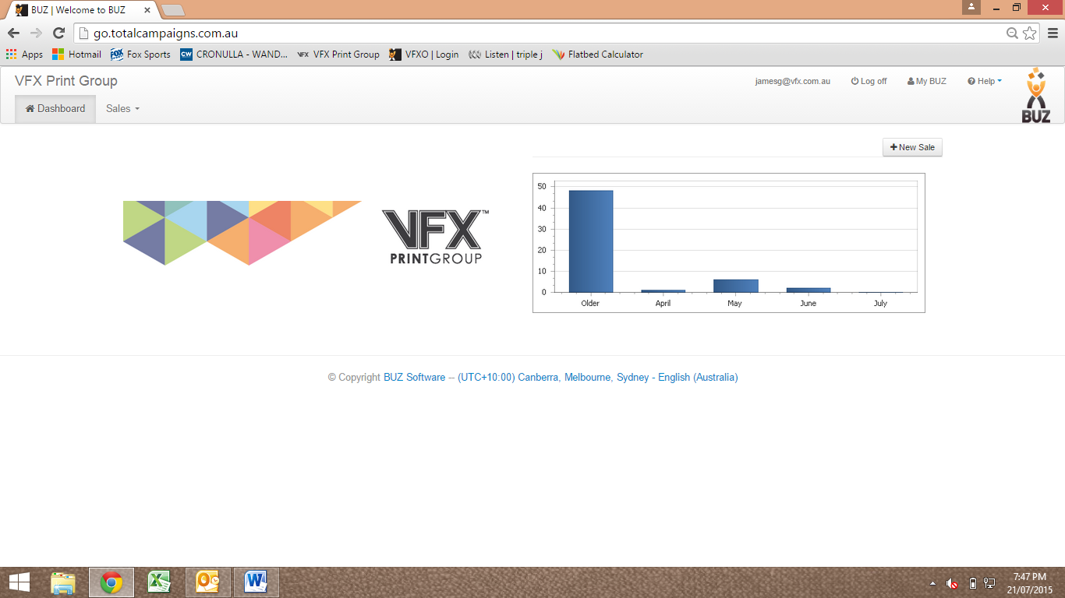

Fill out required fields
Tip: Enter full address into “Reference” section for real estate orders

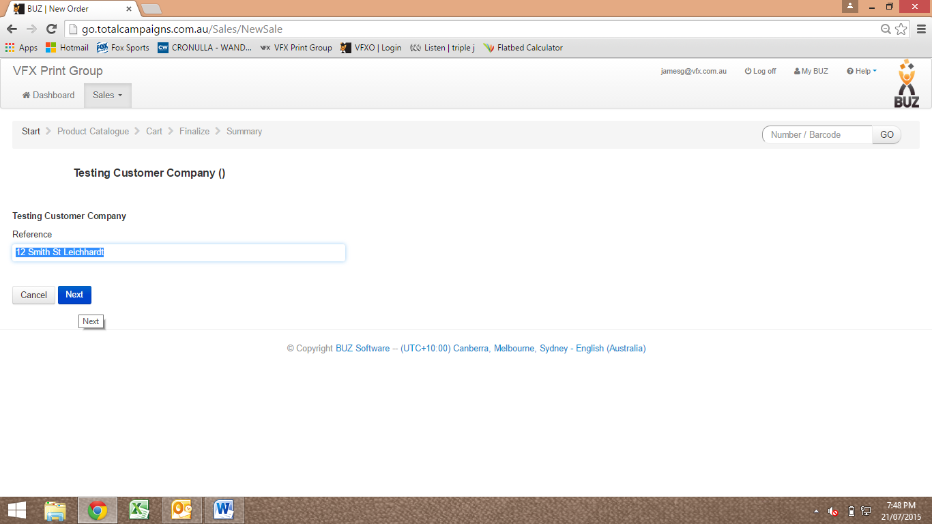

Select product group and fill out questions as required

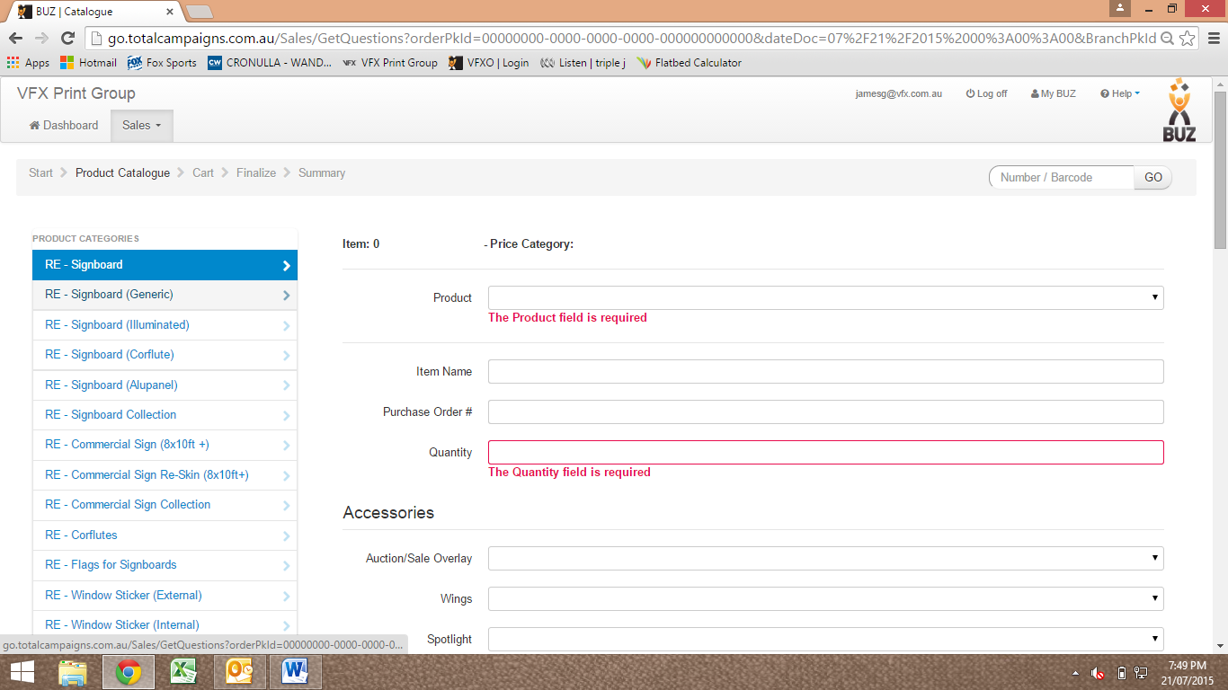

Select “Artwork Type” from the drop down list
For supplied artwork to be send directly to print, select “Supplied print ready artwork”
If a design is required by VFX, select “VFX to design”
Once complete select “Add to Cart”

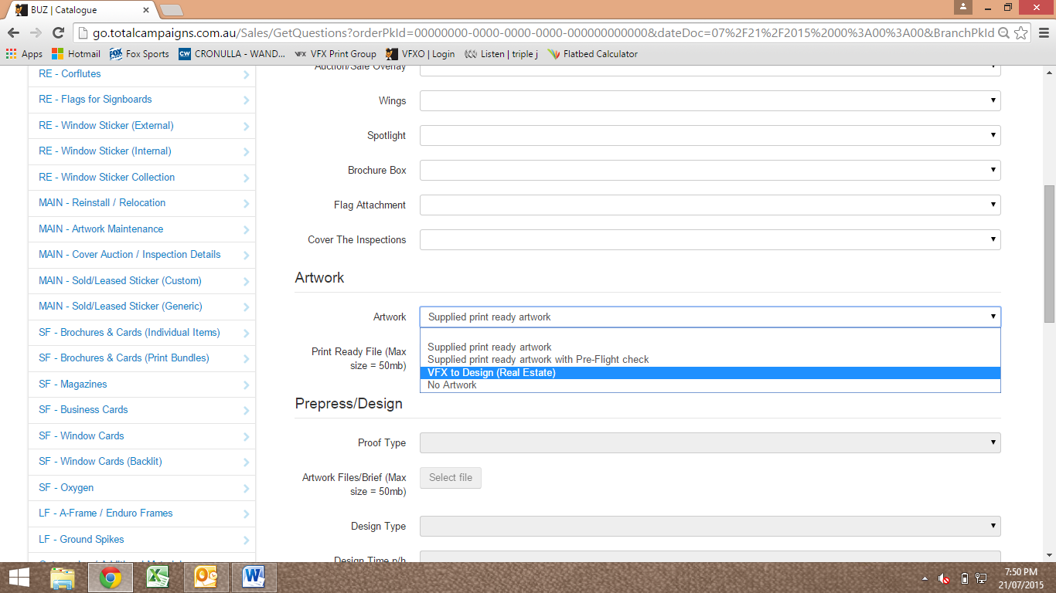

Check items them select “finalise”

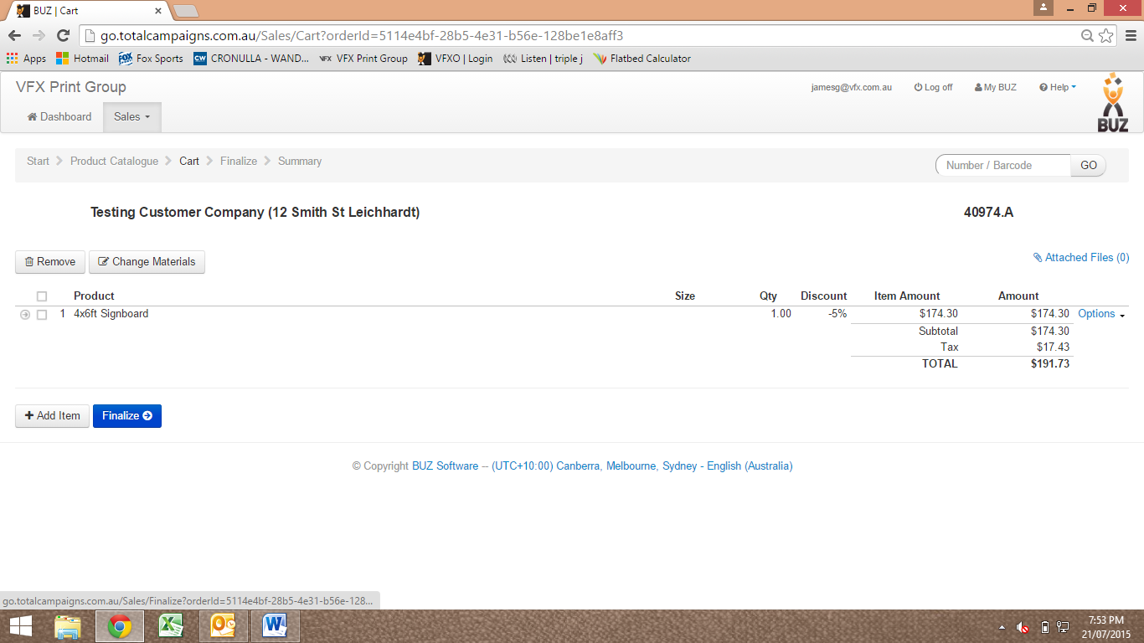

Select dispatch method and fill out other fields where required
Select “Install / Dispatch Address” and ensure details are correct. If not “Add Contact” and follow the prompts

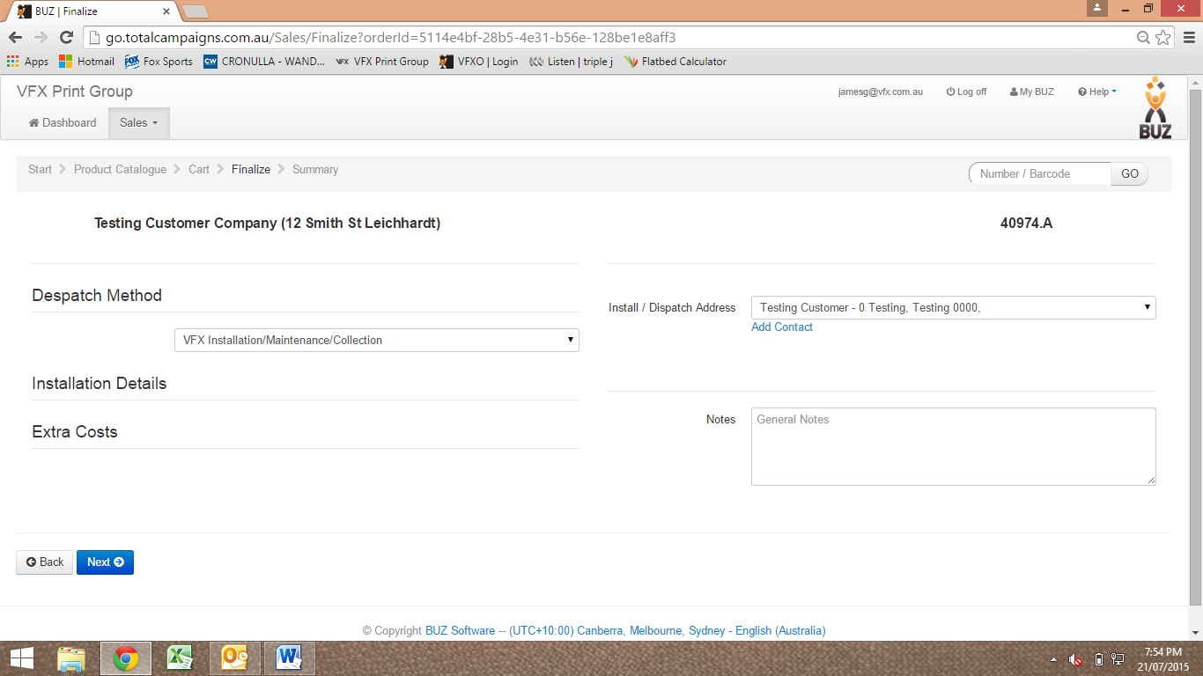

Select date then Select “Confirm”

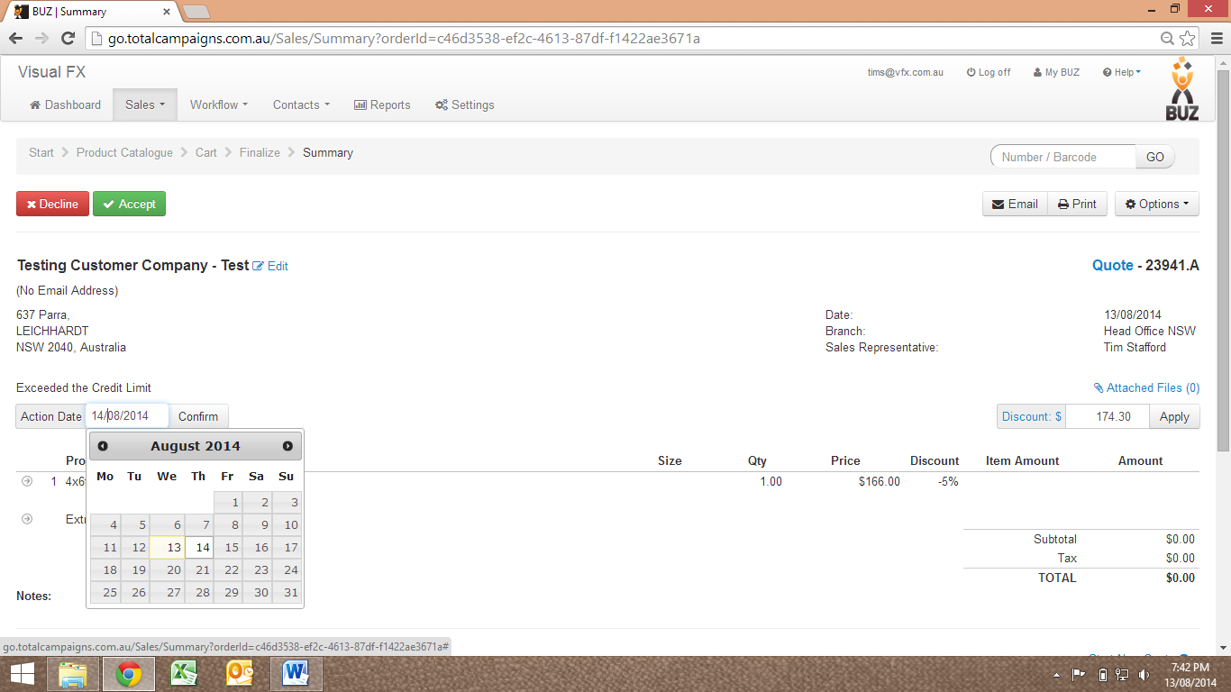

Select “Accept”

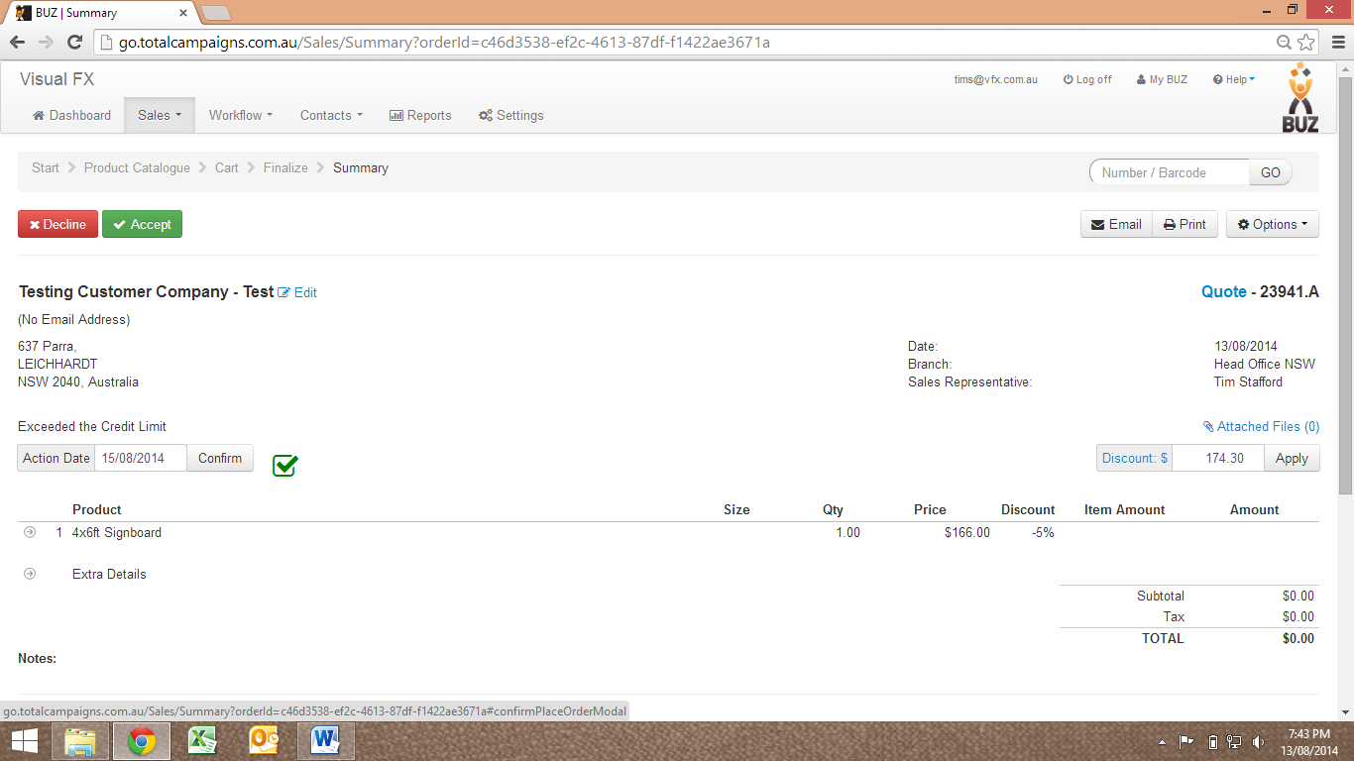

Confirm date the Select “Accept”

